SIMATS ENGINEERING
ASSESSMENT TOOL 1- Enumeration Analysis

COURSE CODE: ITA14 COURSE NAME: Ethical Hacking

COURSE OUTCOME COVERED
CO3: Analyse network services using port scanning, ping sweeps, and enumeration techniques across different operating systems to identify vulnerabilities. (BL3)
Assessment Tool Weightage: 40%

QUESTIONS: 5 Total Marks:100
- A cyber security consulting company has been contracted to perform an initial security assessment of the publicly accessible server scanme.nmap.org. Before conducting any vulnerability assessment, the client requires a detailed enumeration report. Using Nmap, perform host discovery, TCP port scanning, service version detection, operating system fingerprinting, and default script scanning on scanme.nmap.org. Discuss how a threat actor could utilize the information gathered during enumeration to launch further attacks such as service exploitation, brute-force attacks, or vulnerability discovery. Prepare a technical report summarizing your findings, attack surface analysis, risk assessment, and recommendations for securing the server.
Aim :
To enumerate scanme.nmap.org using Nmap and identify its accessible ports, services, service versions, operating system, and additional information obtained through NSE scripts.

Tools :
Kali Linux , Nmap
Commands :
Host Discovery : nmap -sn scanme.nmap.org
Port Scanning : nmap -sS scanme.nmap.org
Service Detection : nmap -sV scanme.nmap.org
OS Detection : sudo nmap -O scanme.nmap.org
NSE Enumeration : nmap -sC scanme.nmap.org
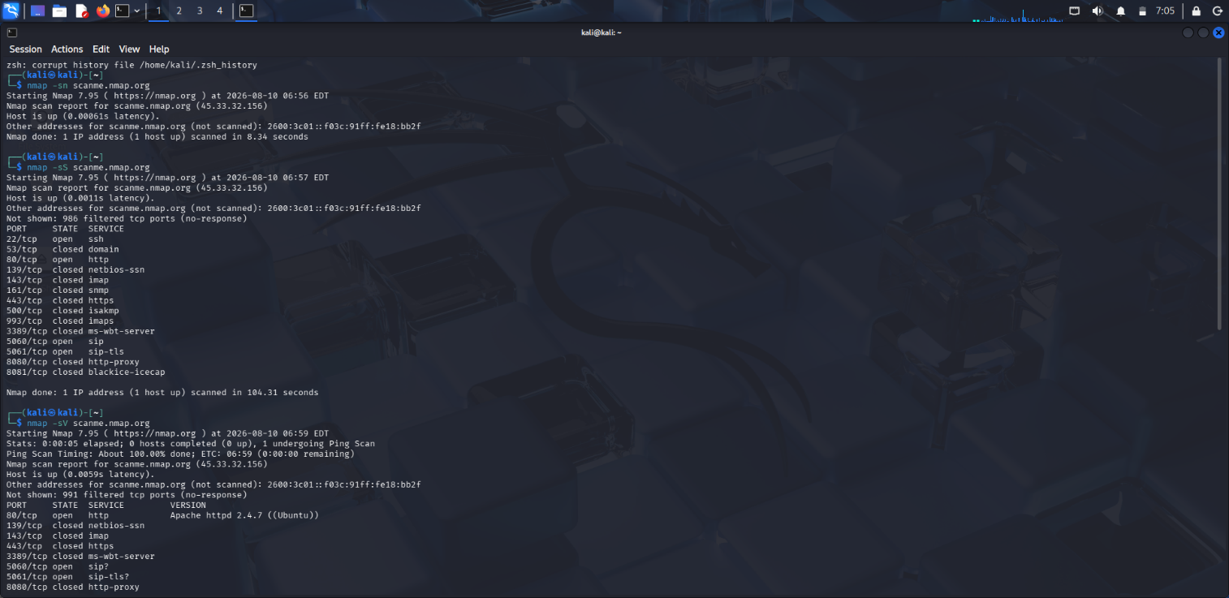
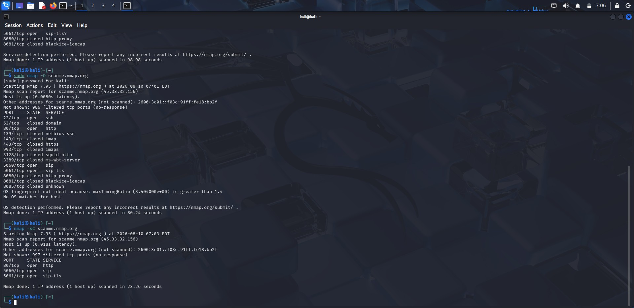

Security Analysis
The discovered services constitute the externally visible attack surface. Service and version information could help an attacker identify suitable vulnerability research targets. Publicly accessible administrative services such as SSH should therefore be appropriately restricted.
Recommendations
- Disable unnecessary services.
- Restrict administrative services.
- Keep software updated.
- Use strong authentication.
- Configure firewall rules.
- Monitor authentication and service logs.
Conclusion
The Nmap assessment successfully enumerated the publicly accessible services and provided information useful for evaluating the target's security exposure. Reducing unnecessary services and securing required services can minimize the attack surface.

- The security team has deployed a deliberately vulnerable Linux server, 192.168.56.101 (Metasploitable 2), in an isolated laboratory environment to train penetration testers. As part of the pre-engagement reconnaissance phase, use Nmap to perform comprehensive enumeration of 192.168.56.101. Analyze the purpose of each service and determine which services could provide potential entry points for an attacker. Categorize the discovered services into High, Medium, and Low risk levels based on their exposure and functionality. Explain how the enumeration results could guide a penetration tester in selecting potential attack vectors and exploitation strategies.
Objective :
To perform comprehensive enumeration of the Metasploitable 2 Linux server using Nmap and identify its open ports, running services, service versions, operating system, and potential security risks.
Target : Metasploitable 2 IP Address : 192.168.56.102
Network : Host-Only Adapter Tool : Nmap
Procedure :
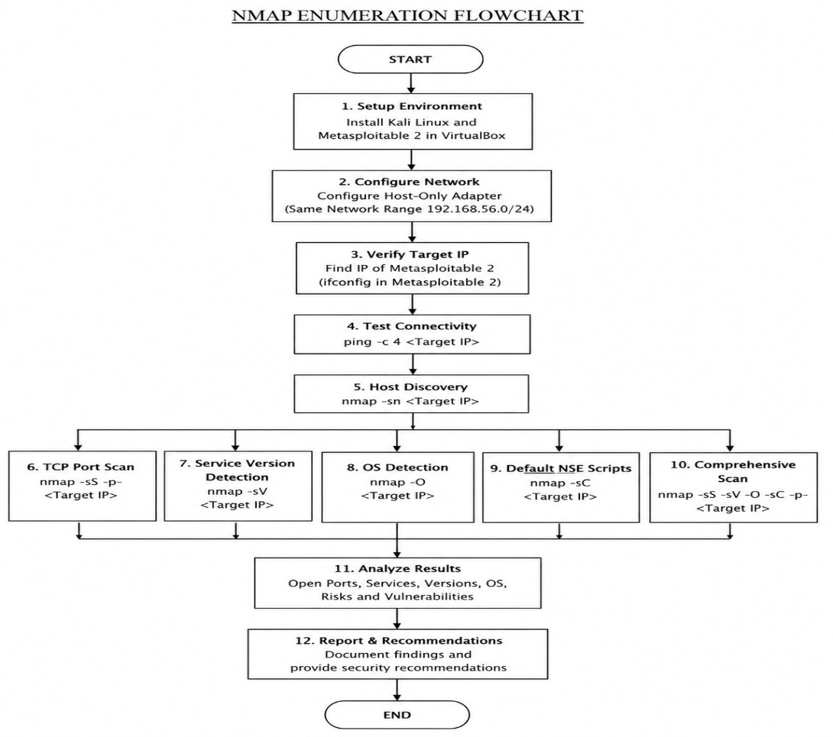

Commands and Results
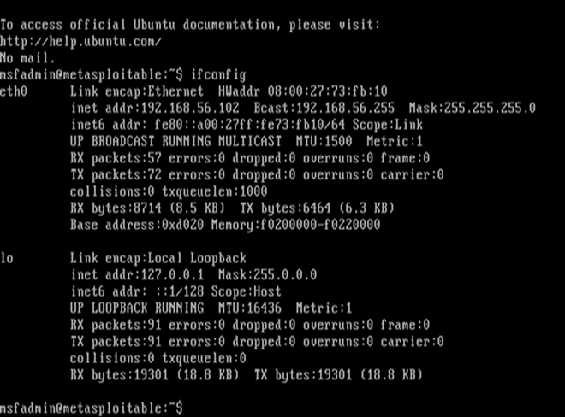
A. Host Discovery
Command : nmap -sn 192.168.56.102
Result : The target was found to be active.
B. TCP Port Scanning
Command : sudo nmap -sS -p- 192.168.56.102
Result : Nmap identified the open TCP ports on the target.
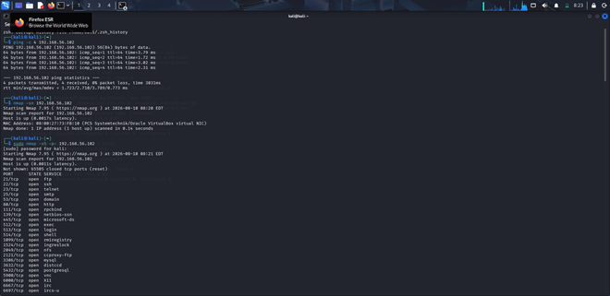

C. Service Version Detection
Command : sudo nmap -sV 192.168.56.10
Result : The services and their versions were identified.

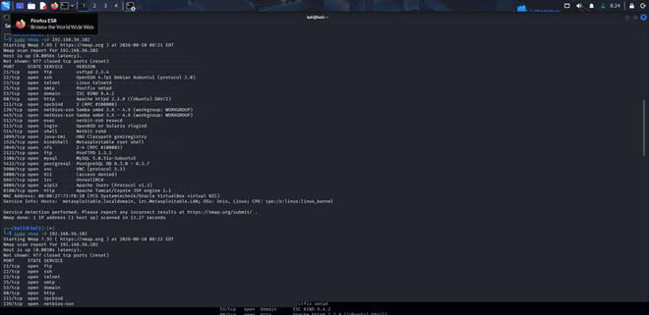
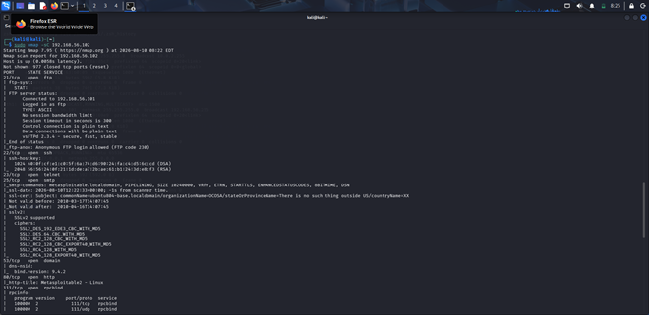

D. Operating System Detection
Command : sudo nmap -O 192.168.56.102
Result : Nmap identified the target as a Linux-based system.

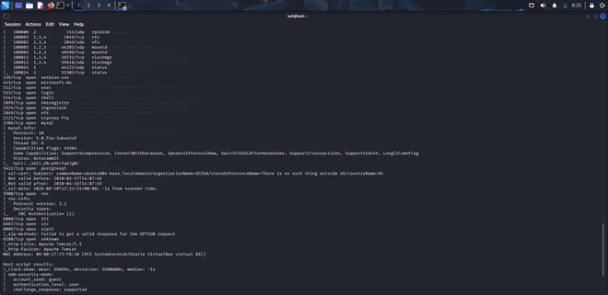

E. Default NSE Scripts
Command : sudo nmap -sC 192.168.56.102
Result : Default NSE scripts provided additional information about the services.
Service Risk Analysis :
- FTP : File transfer - High risk
- Telnet : Remote login - High risk
- HTTP : Web service - High risk
- Database : Data storage/access - High risk
- SSH : Secure remote administration - Medium risk
- SMTP : Mail communication - Medium risk

Recommendations
- Disable unnecessary services.
- Replace Telnet with SSH.
- Restrict database services from network access.
- Keep all software updated.
- Use strong authentication.
- Configure firewall rules

How Enumerations helps a penetration Tester :
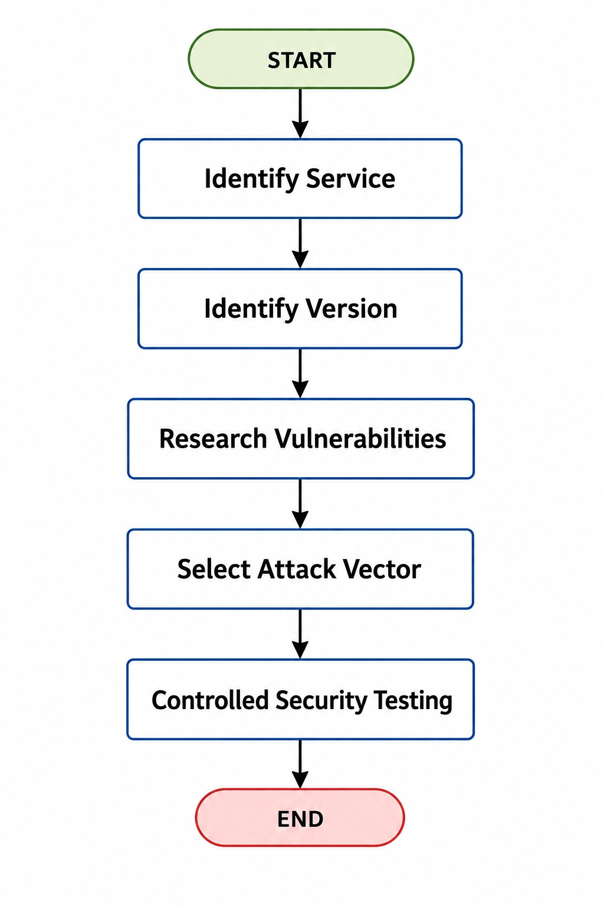

Conclusion
Nmap successfully identified the active host, open ports, running services, service versions, and operating-system information of the Metasploitable 2 server. The discovered services represent different levels of security risk and provide potential entry points that should be prioritized during authorized penetration testing.

- A financial organization wants to assess the security posture of a Windows workstation located at 192.168.56.102 before connecting it to the production network. Using Nmap, enumerate 192.168.56.102 to identify active ports, network services, file-sharing protocols, remote management services, and operating system details. Analyze whether the discovered services comply with the principle of least privilege and identify any services that may unnecessarily increase the attack surface. Discuss how an attacker could leverage the identified services for reconnaissance, lateral movement, or unauthorized access. Based on your findings, propose a set of security hardening measures to improve the system's resilience against cyberattacks.
Objective
The objective was to assess the security of the Windows workstation 192.168.56.102 before connecting it to the production network. Nmap was used to identify open ports, services, file-sharing services, remote-management services, and OS details.
Target: 192.168.56.102
Tool: Nmap
Procedure :
- Configured Windows 11 as the target with IP 192.168.56.102.
- Configured Kali Linux with IP 192.168.56.101 on the same Host-Only network.
- Verified the target using : ip neigh show 192.168.56.102
- Performed Nmap scanning : nmap -Pn 192.168.56.102
- Detected Windows services : nmap -Pn -sV -p 135,139,445,3389,5985,5986 192.168.56.102
- Performed OS detection : sudo nmap -Pn -O 192.168.56.102
Commands :
- ip addr show eth1
- ip neigh show 192.168.56.102
- nmap -Pn 192.168.56.102
- nmap -Pn -sV -p 135,139,445,3389,5985,5986 192.168.56.102
- sudo nmap -Pn -O 192.168.56.102
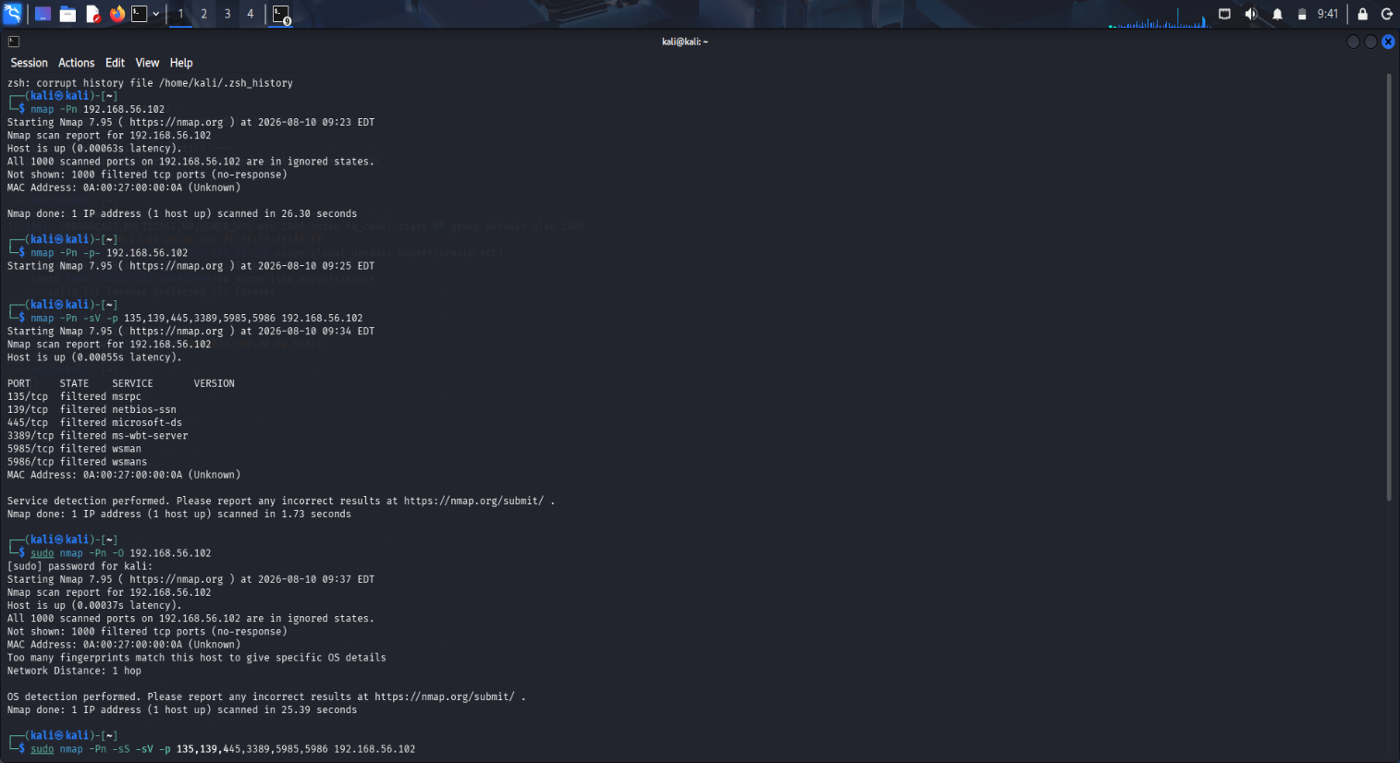
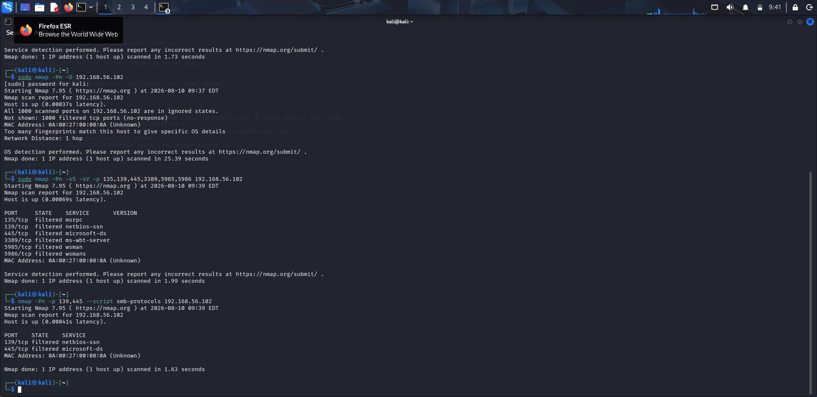
Security Analysis
- Ports 5060 and 5061 were found to be the primary exposed services and are commonly associated with SIP-based VoIP communication.
- If VoIP functionality is not required on the workstation, keeping these ports accessible can create an unnecessary attack surface.
- An attacker who discovers an exposed SIP service may perform further service enumeration to identify its version and configuration.

- A vulnerable or incorrectly configured SIP service could increase the risk of unauthorized access or other attacks.
- Overall, the system has relatively limited network exposure, but the exposed SIP services should be reviewed before the workstation is connected to the production environment.
Recommendations
- Remove or disable SIP/VoIP services if they are not necessary for the workstation's operation.
- If SIP is required, restrict ports 5060 and 5061 to trusted hosts or authorized network segments.
- Keep the SIP application and related components updated with the latest security patches.
- Apply strong authentication and limit administrative access to authorized users.
Conclusion
The assessment shows that the workstation has a relatively restricted network exposure. The main accessible services are associated with SIP communication through ports 5060 and 5061, while SMB, RDP, WinRM, SSH, and NetBIOS were filtered. The SIP services should be reviewed to determine whether they are actually required. Disabling unnecessary services or restricting them to trusted systems will reduce the attack surface and help the workstation follow the principle of least privilege before it is connected to the production network.

- An organization hosts a web application on 192.168.56.103 (OWASP Juice Shop Server) and plans to conduct a full penetration test. Before the testing phase begins, the security team must understand the server's network exposure. Using Nmap, perform a detailed enumeration of 192.168.56.103, including host discovery, port scanning, service version detection, operating system fingerprinting, and web service identification. Analyze the discovered services and determine how they support the hosted web application. Evaluate the risks associated with exposed web services, administrative interfaces, and supporting services. Explain how the information gathered during enumeration could be used to identify potential vulnerabilities in the web application environment and recommend measures to minimize exposure
Aim
To perform network reconnaissance of the OWASP Juice Shop server (192.168.56.103) using Nmap and identify the host's accessible ports, services, operating system, and web application exposure.
Target Information
Target : OWASP Juice Shop Server
IP Address : 192.168.56.103
Tool : Nmap
Platform : Kali Linux
Procedure :
- First, OWASP Juice Shop was started using Docker : sudo docker run -d --name juice-shop -p 3000:3000 bkimminich/juice-shop
- The target IP was configured : sudo ip addr add 192.168.56.103/24 dev eth1
- Connectivity was verified : ping -c 4 192.168.56.103
- Host discovery was performed : nmap -sn 192.168.56.103
- The host was found to be up.
- All TCP ports were scanned : nmap -sT -p- 192.168.56.103

- Service and version detection : nmap -sT -sV 192.168.56.103
- OS detection : sudo nmap -sT -O 192.168.56.103
Commands :
- sudo docker run -d --name juice-shop -p 3000:3000 bkimminich/juice-shop
- sudo ip addr add 192.168.56.103/24 dev eth1
- ping -c 4 192.168.56.103
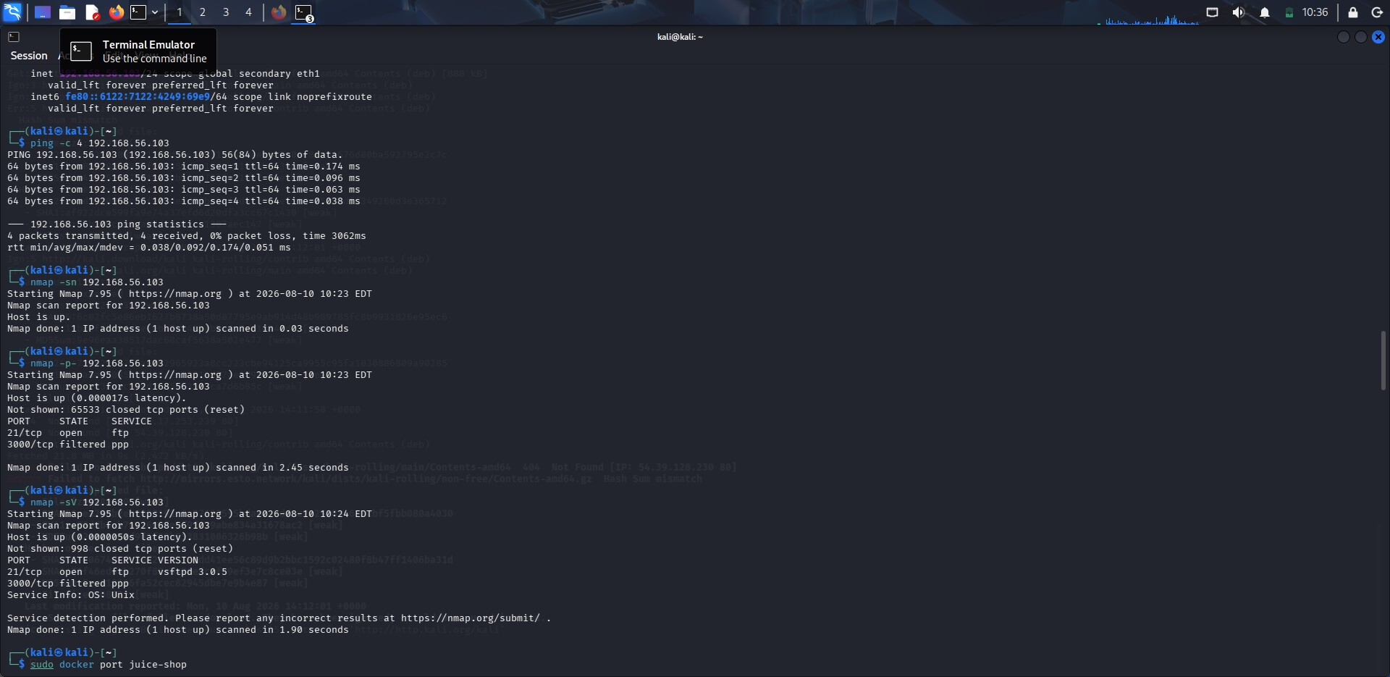

- nmap -sn 192.168.56.103
- nmap -sT -p- 192.168.56.103
- nmap -sT -sV 192.168.56.103

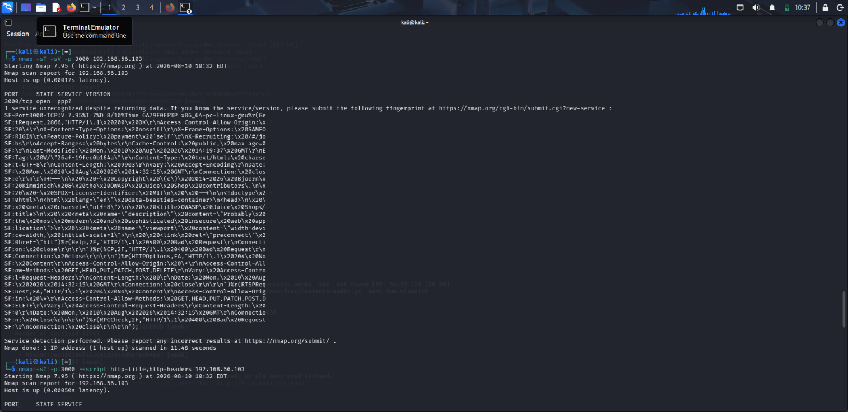
- sudo nmap -sT -O 192.168.56.103
- sudo nmap -sT -A 192.168.56.103
- curl -I http://192.168.56.103:3000
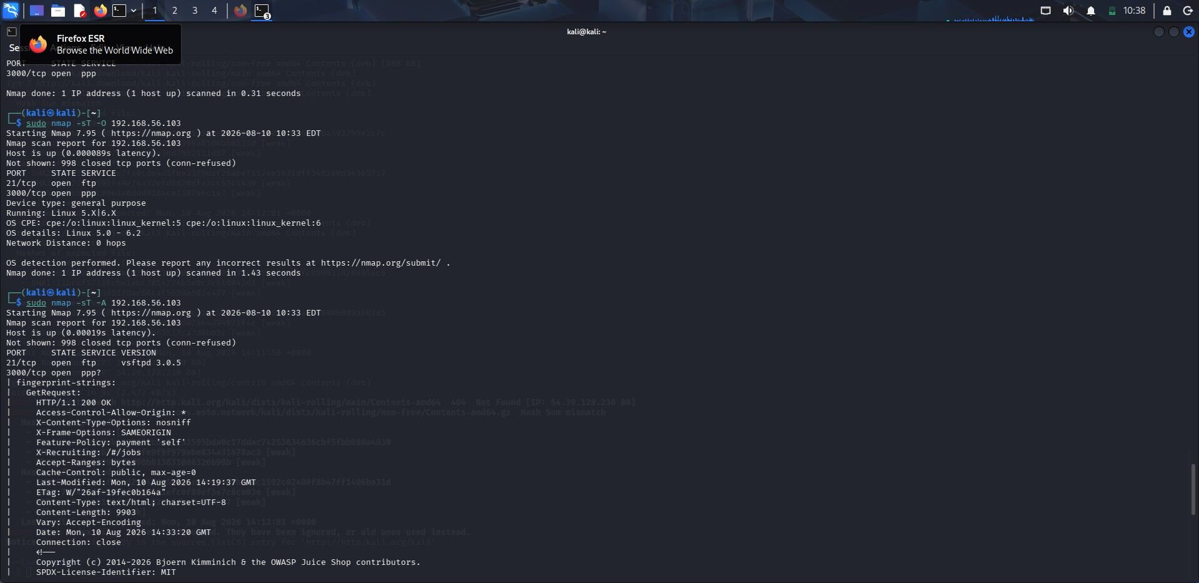
Enumeration Results
The scan provides details about the open ports and services running on 192.168.56.103. The web service is the main component of interest because it provides access to the Juice Shop application.

Risk Assessment
- The enumeration information can help a penetration tester understand how the server is exposed to the network.
- Open web ports can be examined for application-level weaknesses, while service versions can be checked against known security vulnerabilities.
- Exposed administrative services may allow attackers to attempt unauthorized authentication or exploit weaknesses in outdated software.
- Unnecessary services also increase the number of possible entry points into the system.
Recommendations
- Close ports that are not required.
- Restrict SSH and other management services to authorized users and networks.
- Keep the OS, web server, and application dependencies updated.
- Enable HTTPS for secure communication.
- Hide unnecessary server and version information.
- Use firewalls to control incoming connections.
- Separate public web services from administrative interfaces.
- Perform periodic Nmap scans to identify unexpected changes.
Conclusion
The Nmap assessment of 192.168.56.103 provides important information about the server's network exposure and the services supporting the OWASP Juice Shop application. The results can be used to identify potential entry points and guide further vulnerability assessment. Reducing unnecessary services, restricting administrative access, applying security updates, and implementing proper network controls can significantly reduce the server's exposure.

5. The network gateway device at 192.168.56.1 serves as the primary access point between the internal laboratory network and external networks. The network administrator suspects that unnecessary management services may be exposed. Using Nmap, conduct a comprehensive enumeration of 192.168.56.1, including port scanning, service detection, operating system fingerprinting, and script-based enumeration. Identify all exposed management interfaces, network services, and accessible resources. Analyze the security implications of exposing services such as SSH, Telnet, SNMP, HTTP, or HTTPS management interfaces. Discuss how attackers could exploit misconfigured management services to gain unauthorized access to the network infrastructure. Based on your analysis, recommend security controls and best practices to secure the gateway device and reduce the risk of compromise.
Objective :
To enumerate the gateway device 192.168.56.1 using Nmap, identify exposed ports and services, detect management interfaces, perform OS and script-based enumeration, analyze security risks, and recommend controls to reduce the attack surface.
Procedure :
- Host Discovery : sudo nmap -sn 192.168.56.1
Purpose: Checks whether the target host is active and reachable.
Result: Host 192.168.56.1 is UP.
- TCP Port Scan : sudo nmap -Pn -T4 --top-ports 1000 192.168.56.1
Purpose: Scans the 1,000 most common TCP ports to identify exposed services.
Result: 8 TCP ports were found open: 135, 139, 445, 2179, 2869, 3306, 5357, 16992.

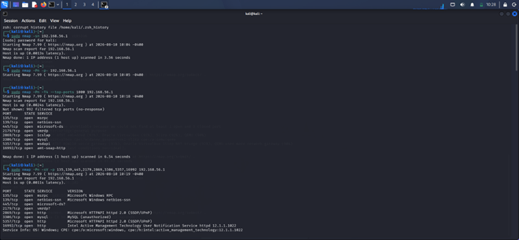
- Service and Version Detection : sudo nmap -Pn -sV -p 135,139,445,2179,2869,3306,5357,16992 192.168.56.1
Purpose: Identifies the services and available version information running on open ports.
- UDP Port Scan : sudo nmap -Pn -sU --top-ports 100 192.168.56.1
Purpose: Identifies commonly exposed UDP services such as NTP, NetBIOS, IKE and UPnP.
Result: UDP 1900 was confirmed open for UPnP; several other ports were reported as open/filtered.
- Operating System Detection : sudo nmap -Pn -O 192.168.56.1
Purpose: Attempts to identify the operating system and device type.
Result: OS detection was inconclusive. Nmap suggested possible gateway/bridge/virtualized device types, but no exact OS match was confirmed.

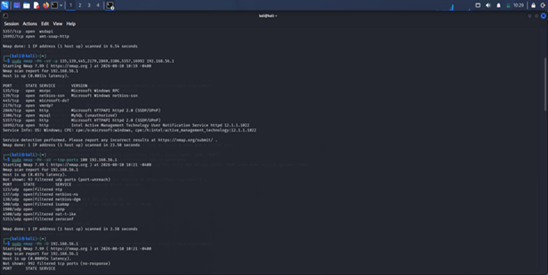

6. Default NSE Script Enumeration : sudo nmap -Pn -sC -sV -p 135,139,445,2179,2869,3306, 5357, 16992 192.168.56.1
Purpose: Uses Nmap's default scripts along with service detection to collect additional information about exposed services.
Result: SMB security information, HTTP information and Intel AMT information were identified.
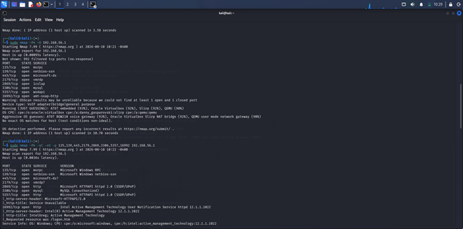

- Management Port Check : sudo nmap -Pn -sV -p 22,23,80,443,161,162 192.168.56.1
Purpose: Checks common management services such as SSH, Telnet, HTTP, HTTPS and SNMP.
Result: All checked management ports were closed.

- SMB Security Enumeration : sudo nmap -Pn -p 139,445 --script smb-protocols,smb2-security-mode,smb2-time 192.168.56.1
Purpose: Identifies SMB versions and checks SMB security settings.
Result: SMB 3.1.1 message signing was enabled and required.
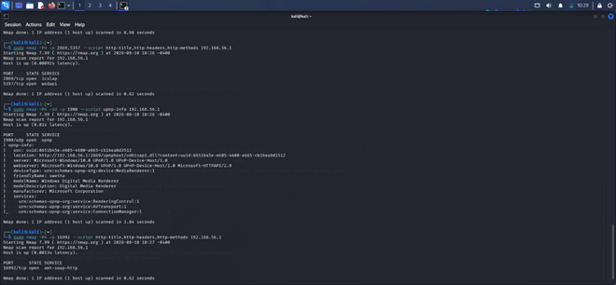
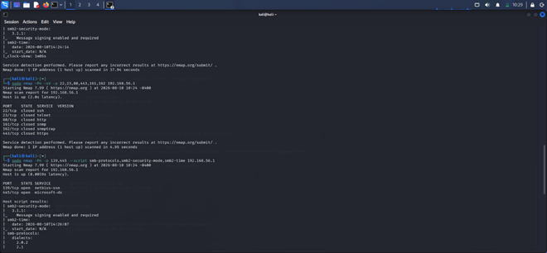

Service Risk Analysis
- 135 - MSRPC: Windows communication service;
- 139 - NetBIOS: Supports network sharing; can help attackers gather information.
- 445 - SMB: File-sharing service; exposed SMB may allow unauthorized access.
- 2179 - VMRDP: Service not fully identified, should be checked , disabled if unused.
- 2869/5357 - HTTPAPI/UPnP: may expose system details.
- 3306 - MySQL: Database service; should only be accessible to authorized systems.
- 16992 - Intel AMT: Remote management service; should be strongly restricted.
- 1900 - UPnP: Advertises device information; disable if not required.
Security Implications
The exposed services increase the gateway's attack surface. An attacker with network access could perform service enumeration, authentication attacks, or exploit vulnerable services. SMB, MySQL, UPnP, and Intel AMT are the main services requiring attention.
Recommended Security Controls
- Disable unnecessary services and ports.
- Restrict SMB/NetBIOS to trusted systems.
- Restrict MySQL to authorized hosts.
- Disable UPnP if not required.
- Allow Intel AMT only from a secure management network.
- Use firewalls and strong authentication.
Conclusion
The assessment found several exposed TCP and UDP services on 192.168.56.1. SSH, Telnet, HTTP, HTTPS, and SNMP were closed, but SMB, MySQL, UPnP, and Intel AMT were accessible. Restricting unnecessary services and applying proper firewall, authentication, patching, and network segmentation controls will reduce the gateway's security risk.

Code of Conduct:
I Gurram Roshitha 192373027 certify that this submission is my original work and that I have adhered to the guidelines specified for this assessment. I understand that any violation of academic integrity rules will result in disciplinary action.
Signature of the Student: Gurram Roshitha

RUBRICS FOR CALCULATION
Criteria | Weightage (%) | Level 4 (Exemplary) | Level 3 (Proficient) | Level 2 (Developing) | Level 1 (Beginning) | Mark
Conceptual Understanding | 20% | Demonstrates strong understanding of underlying concepts in the simulation | Shows good understanding with minor gaps | Partial understanding; some misconceptions | Lacks understanding of key concepts
Model Design | 25% | Develops accurate, well-structured simulation/model independently | Develops correct model with minor errors | Model is incomplete or requires guidance | Unable to develop a proper model
Tool Usage | 20% | Uses simulation tools effectively with correct setup and execution | Uses tools with minor errors or guidance | Limited ability to use tools properly | Unable to use simulation tools
Analysis of Results | 20% | Provides clear, logical analysis and meaningful interpretation of results | Analysis is reasonable with minor gaps | Superficial analysis; limited interpretation | Unable to analyze or interpret results
Documentation | 15% | Presents results clearly with proper documentation and structured reporting | Documentation is adequate with minor issues | Poorly organized or incomplete documentation | No proper documentation or presentation

